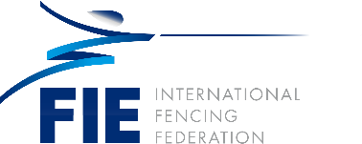

PROF. DR. MURAT ATALI (TÜR)

Education:
- 1990: Ankara University Faculty of Law (bachelor’s degree)
- 1993: Selçuk University Institute of Social Sciences (Master’s degree)
- 2001: Regensburg (Germany) University Faculty of Law (PhD)

Work Experience and Sport:
- 2008-2015: Bilkent Universty, Associate Professor
- 2015-2017: Turkish-German University, Vice Rector
- 2017- : Istanbul University, Faculty of Law, Full Professor (Civil Procedure and Bankruptcy Law)
- 2007-2015: Board Member of the Turkish Fencing Federation
- 2015-2021: Member of the General Assembly of Istanbul Arbitration Center
- 2015-2024: President of the Turkish Fencing Federation
- 2021-2024: Member of the Legal Commission, (FIE)
- 2021-2024: Member of the Legal Commission, (EFC)
- 2024 – : FIE Executive Committee member - Representative of the Executive Committee in the Legal Commission

